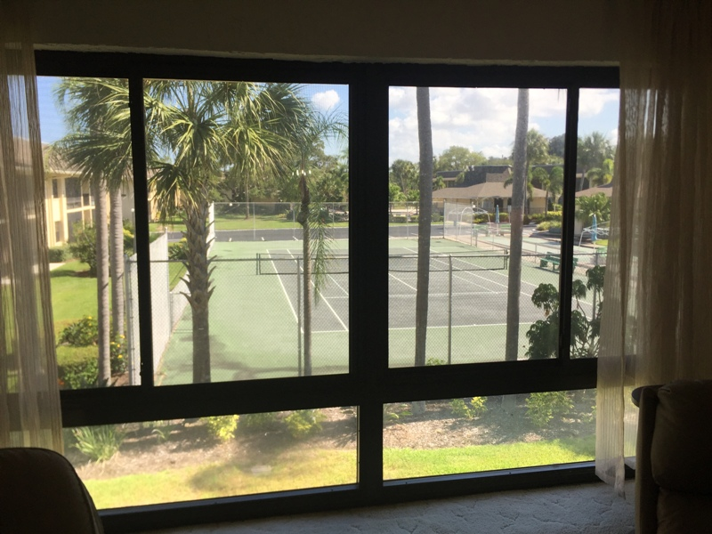 | 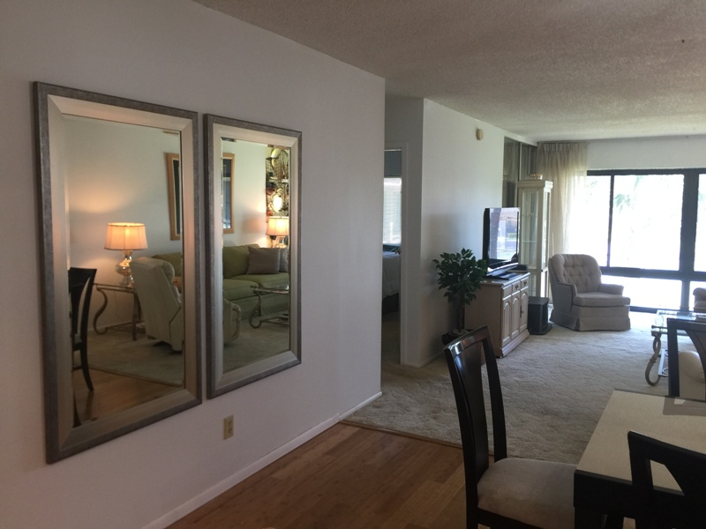
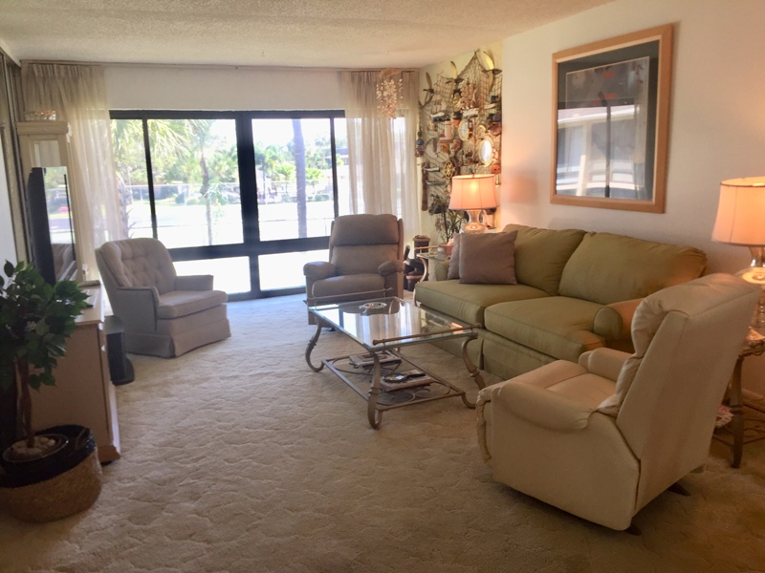 | 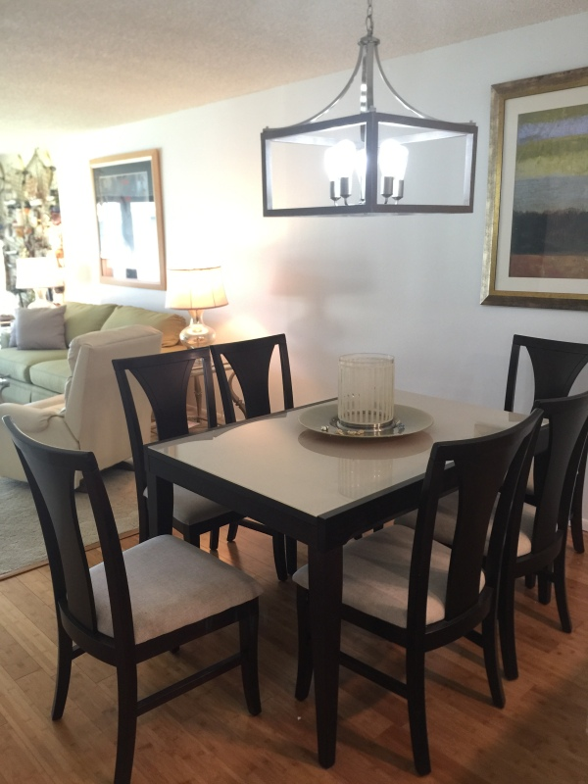
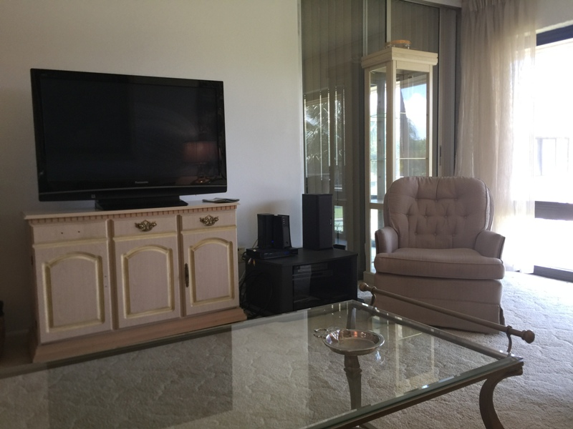 | 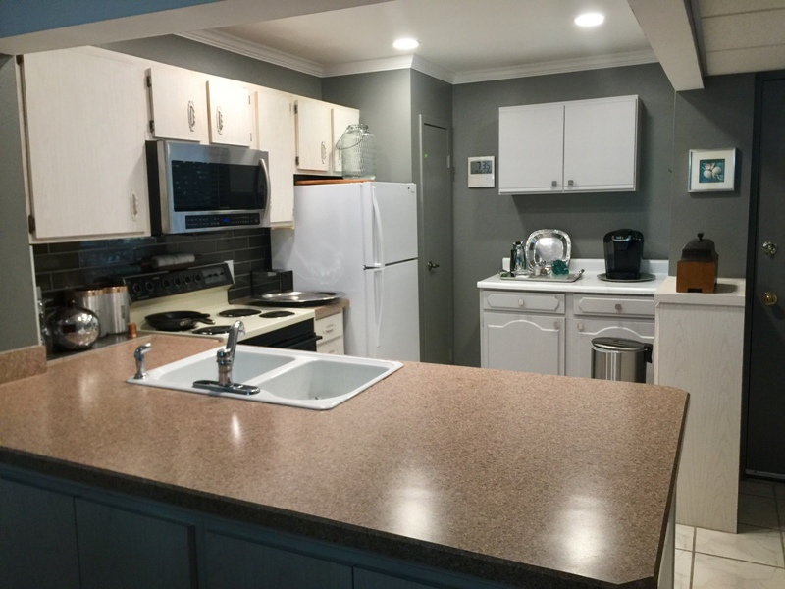
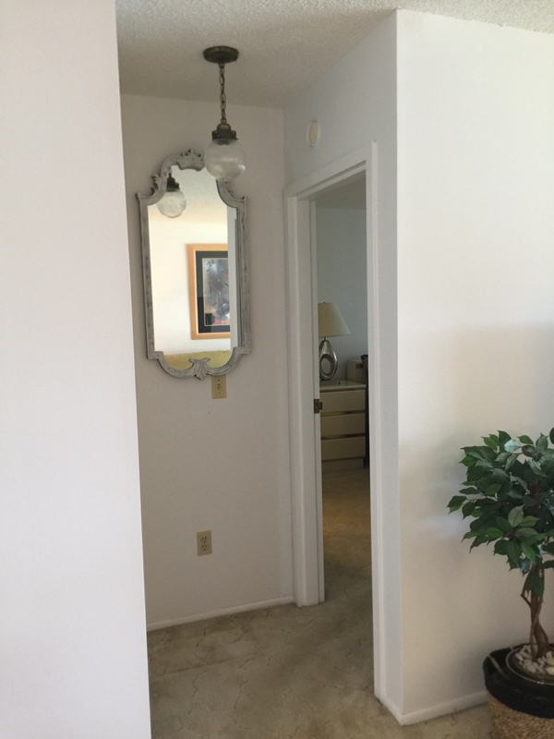 | 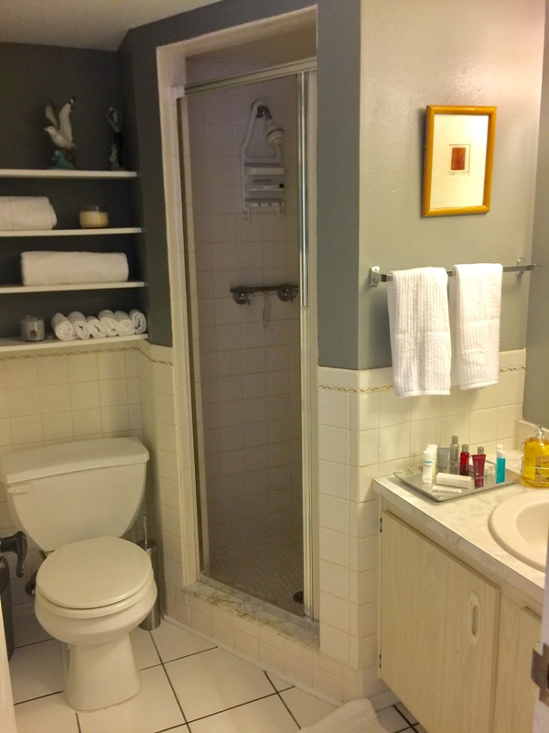
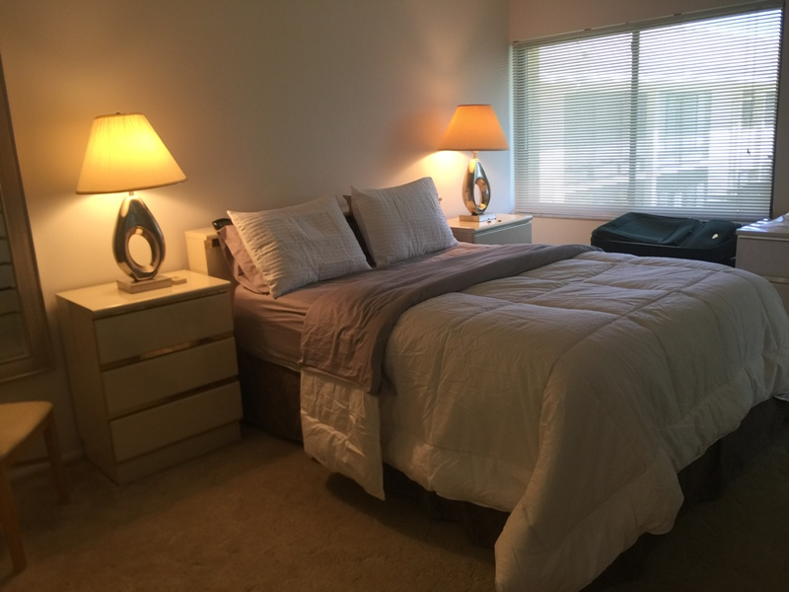 | 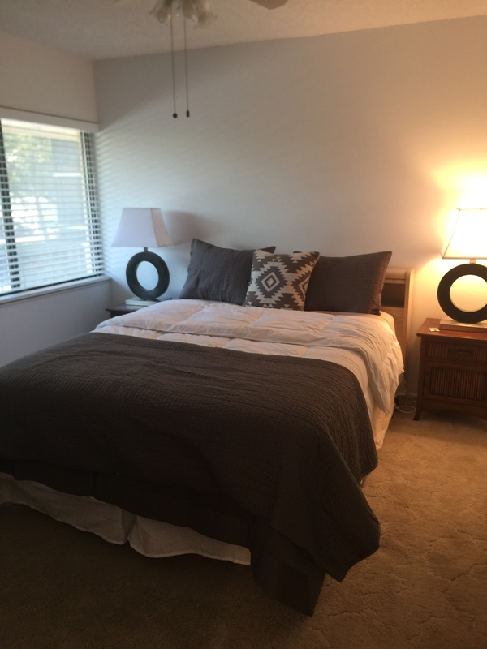
Upgrades are:
Fresh paint thru-out 60 days ago. approx $3000.00 (color in photos shows blue in some places but all are white. kitchen and bathrooms are Sherman Williams ...Classic French Grey.
New carpet in same color tone will be installed next week in living, bedrooms, closets.$2900.00
Porch area has been opened to living with new windows. $$2300.00
Bosch dishwasher 2014 approx $400.00
New Whirlpool Microwave this year. approx $276.00
Renovated Kitchen with recessed lighting this year $ 2800.00.
New 2 ton Air-conditioner in October 2016. approx.$4530.00

